# Appendix B

# Suitability assessment based on Spatial Multi-Criteria Decision method for different marine use types

In this paper, the suitability for five marine use types in the case study is meanly evaluated by the Spatial Multi-Criteria Decision (SMCD) method. Some marine use type is evaluated by their specific standards. This Appendix will describe the process and results of the evaluation. The marine use types include wind farm, salt production, fishery, ship navigation, recreation and ecological production. To focus on the marine space’s natural resource assessment, the natural environmental factors are meanly selected. The factor for assessing the suitability of each marine use type are shown in Figure 1.

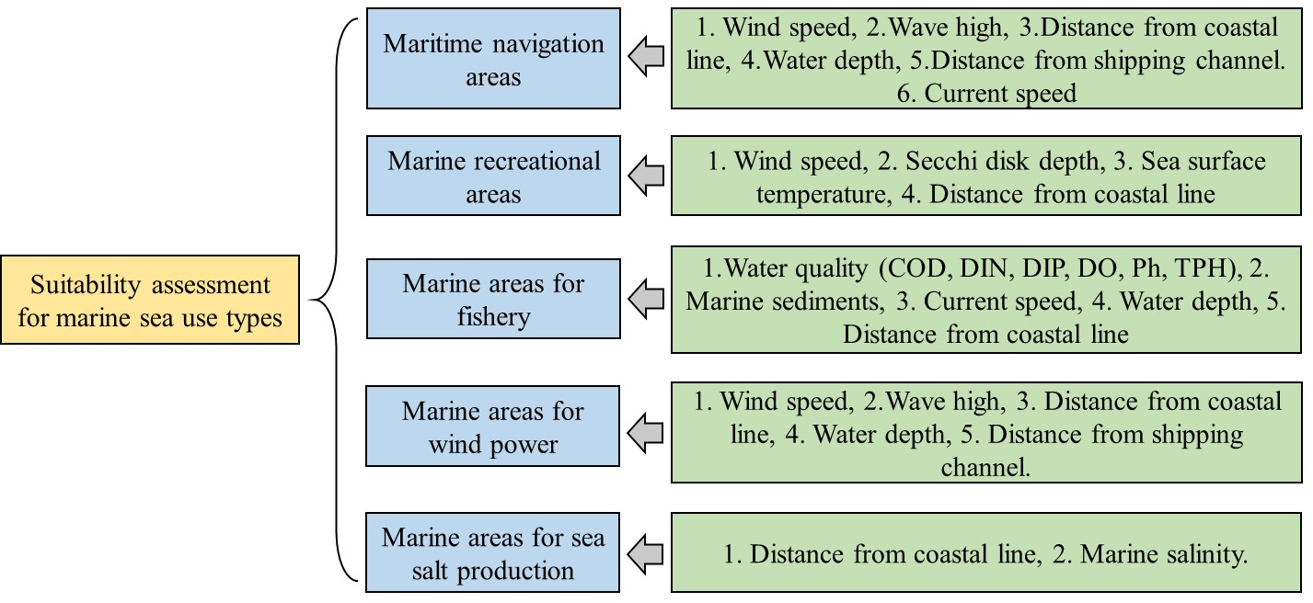

**Figure 1** The criteria for evaluating the suitability of different marine use types

# Method

The SMCD method includes four key steps: criteria selection, data normalization, criteria weighting, and weighted summation to obtain the final assessment results. Data standardization are used to make the criteria data compared at the same level (0-1). It also could establish the association between the environmental factors and assessment criteria for the evaluated objective. We use a specific threshold to represent the demand of a marine use type to a criterion. The standardization function for positive criteria (The higher values have the greater impact) is shown in Eq. (1), as follows:

(1)

Where the represent the original value of the factor, and the is the standardized value. The represent the threshold of the criterion, and the is the theoretical minimum value of the criterion for the assessment objective. For example, the for wind speed is 0 m/s, and for temperature, it might be -10℃. This method could ensure a uniform standardization scale for every data of the criterion.

For the negative criteria (The smaller values have the greater impact), the standardization function is shown in Eq. (2).

(2)

Where the is the maximum values of the factors. For example, the water depth is a negative criterion for ship’s navigation, the smaller the water depth, the greater the of a ship aground risk. The for water depth could be 20-30m according to the ship tonnage, since the ship can ignore the risk in enough depths of water, and the risk is 0.

Some other criteria such as water quality do not have the continuous values, but discrete levels. The levels will be mapped to 0-1 by equally space according to their standards which will be described in detail in the corresponding section.

The suitability results in SMCD are obtained by linear weighted summation method. The weight for each criterion is generally obtained by subjective or objective weighting method. In this paper, the weighting process is not the main concern, we refer the appropriate domain knowledge to determine the final weights for each criterion. The linear weighted summation for results can be obtained by Eq. (3).

(3)

Some marine use’s suitability results are calculated directly by the standard divide rules, which are also described in the corresponding sections. The result layers could be graded to distinguish more clearly between levels of suitability, and the levels can be in intervals of 0.2.

# The suitability assessment parameters and results

## 2.1 The suitability assessment for ship navigation marine use

The environmental factors for assessing the ship navigation marine use suitability include the wind speed, wave high, distance from coastal line, water depth, distance from ship channel, and current speed. We meanly used data from 2023 as the data sample. The data is from the different source, which is listed in Table 1.

**Table 1** The data sources for evaluating the suitability of ship navigation marine use

|  |  |  |  |
| --- | --- | --- | --- |
| Marine use type | Data name | Time | Data source |
| Marine use for ship navigation | Wind speed | 2023  month mean | EAR5 datasets from https://cds.climate.copernicus.eu/ |
| Wave high | 2023  month mean | EAR5 datasets from https://cds.climate.copernicus.eu/ |
| Current speed | 2023  3 hours intervals | Publicly available from HYCOM datasets in https://www.ncei.noaa.gov/thredds-coastal/catalog/hycom_sfc/catalog.html |
| Water depth | — | ETOPO1 dataset from https://www.ncei.noaa.gov |
| Distance from coastal line | — | Coastal line is publicly available from https://www.ngdc.noaa.gov/mgg/shorelines/shorelines.html |
| Distance from ship channel | — | Ship routes are officially recommended  by Maritme Safety Admininstration of the  People’s Republic of China |

The Standardization function for ship navigation marine use reference research of (Du *et al.*, 2023). The data for calculation is preprocessed by missing value filling and spatial interpolation to unify the spatial resolution. The annual mean of the data is used to perform the standardization. The criteria’s standardization function and their weights are performed in Table 2

**Table 2** The Standardization function and weights for evaluating the suitability of ship navigation marine use

|  |  |  |  |
| --- | --- | --- | --- |
| Criteria | Positive/ negative | Standardization function | Weight |
| Wind speed  (annual mean) | Negative |  | 0.2 |
| Wave high  (annual mean) | Negative |  | 0.2 |
| Current speed  (monthly mean) | Negative |  | 0.05 |
| Water depth | Positive |  | 0.25 |
| Distance from coastal line | Positive |  | 0.2 |
| Distance from ship channel | Negative |  | 0.1 |

According to those function and weights, the standardization results and the suitability assessment result for ship navigation marine use are performed in Figure 2. Figure 2 (a-f) is the standardization layers for each criterion, and the Figure 2 (g) represents the assessment result.

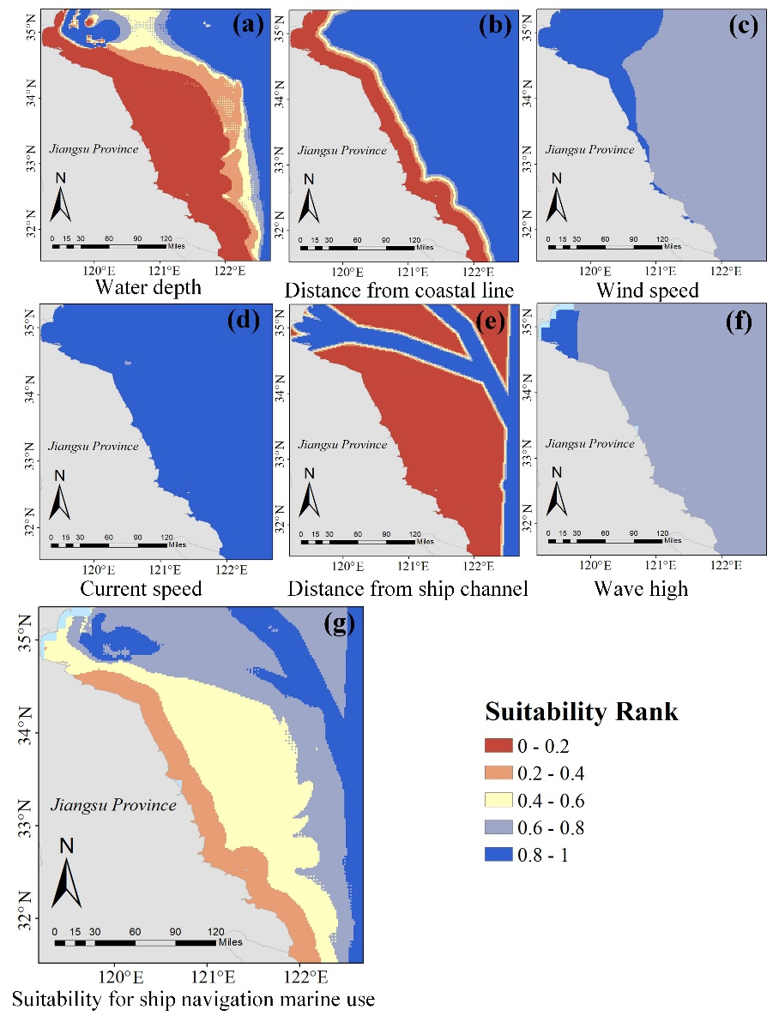

**Figure 2** Standardized layers for each criterion and the suitability assessment result for ship navigation marine use

## 2.2 The suitability assessment for recreational marine use

The environmental factors for assessing the suitability of recreational marine use include the wind speed, sea surface temperature, coastal line distance, and Secchi disk depth. The Secchi disk depth can reflects the transparency of the sea water. The data source is listed in table 3.

**Table 3** The data sources for evaluating the suitability of recreational marine use

|  |  |  |  |
| --- | --- | --- | --- |
| Marine use type | Data name | Time | Data source |
| Recreational marine use | Wind speed | 2023  month mean | EAR5 datasets from https://cds.climate.copernicus.eu/ |
| Sea surface temperature | 2023  3 hours intervals | Publicly available from HYCOM datasets in https://www.ncei.noaa.gov/thredds-coastal/catalog/hycom_sfc/catalog.html |
| Coastal line distance | — | Coastal line is publicly available from https://www.ngdc.noaa.gov/  mgg/shorelines/shorelines.html |
| Secchi disk depth | 2019  month mean | Publicly available from https://www.geodata.cn/data/  datadetails.html?dataguid=1304102 |

The suitability for recreational marine use is graded according to factor conditions. Three rank is divided according to the Chinese national standard of Sea bathing service norms (HY/T 0276-2019). The suitability values for each rank is 1, 0.6, and 0.2, respectively. The rules for assessment are shown in Table 4.

Table 4 The rules for assessing the suitability of recreational marine use

|  |  |  |  |
| --- | --- | --- | --- |
| Factor name | Rank 1 | Rank 2 | Rank 3 |
| Wind speed  （annual average） | <5.4m/s | <10.7m/s | ≥10.7m/s |
| Sea surface temperature  （annual average） | ≥18℃ and ≤28℃ | 15-18℃ or 28-33℃ | ≤15℃ and ≥33℃ |
| Coastal line distance | ≤2km | 2-4km | ＞4km |
| Secchi disk depth  （annual average） | >1.2m | 0.5-1.2m | ＜0.5m |

The suitability for recreational marine use is assessed by standard rules. The original data and suitability assessment result are performed in Figure 3, where Figure 3 (a-d) performed the original data for each criterion, and the Figure 3 (e) demonstrates the suitability result.

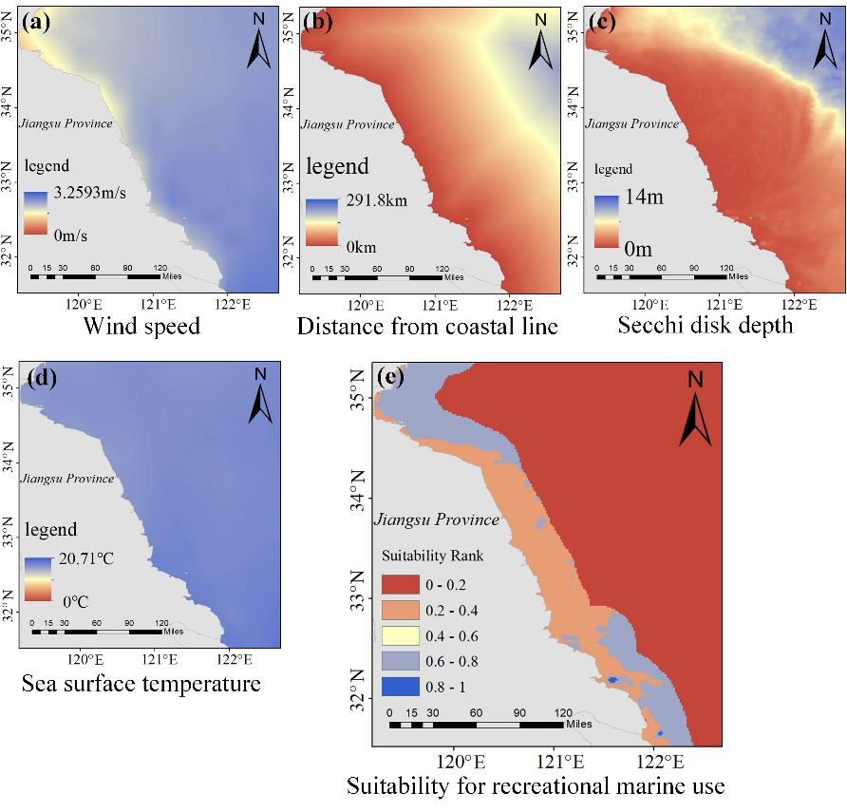

**Figure 3** The original data for each criterion and suitability assessment result for recreational marine use

## 2.3 The suitability assessment for fishery marine use

The environmental factors for assessing the fishery marine use suitability include the sea water quality (which is assessed by six sea water chemical composition including COD (Chemical Oxygen Demand), DIN (Dissolved Organic Nitrogen), DIP (Dissolved Inorganic Phosphorus), DO (Dissolved Oxygen), Ph, and TPH (Total Petroleum Hydrocarbon)), current speed, water depth, distance from coastal line and marine sediments. The data source is listed in Table 5. The chemical components for sea water quality are preprocessed by Kriging interpolation method to interpolate sparse points into continuous surfaces.

**Table 5** The data sources for evaluating the suitability of fishery marine use

|  |  |  |  |  |
| --- | --- | --- | --- | --- |
| Marine use type | Data name | | Time | Data source |
| Fishery marine use | Water quality | COD | Average of May, June, July and August in 2022 | Publicly available from https://doi.org/10.6084/m9.figshare.22584742 |
| DIN |
| DIP |
| DO |
| PH |
| TPH |
| Current speed | | 2023 month mean | Publicly available from HYCOM datasets in https://www.ncei.noaa.gov/thredds-coastal/catalog/hycom_sfc/catalog.html |
| Water depth | | 2023 month mean | ETOPO1 dataset from https://www.ncei.noaa.gov |
| Distance from coastal line | | — | Coastal line is publicly available from https://www.ngdc.noaa.gov/  mgg/shorelines/shorelines.html |
| Marine sediments | | 2019 month mean | Original thematic maps derived from https://geocloud.cgs.gov.cn/ |

The sea water quality is divided into four grades according to the Chinese national standard (GB 3097-1997). The detailed rules are shown in Table 6.

**Table 6** The class rules for sea water quality

|  |  |  |  |  |  |  |
| --- | --- | --- | --- | --- | --- | --- |
| Factor name | COD | DIN | DIP | DO | PH | TPH |
| Class 1  (1) | ≤2 | ≤0.2 | ≤0. 015 | ≥6 | ≥7.5 and <8.5 | ≤0.05 |
| Class 2  (0.75) | >2 and ≤3 | >0.2 and ≤0.3 | >0. 015 and ≤0.03 | ≥5 and <6 | ≥7.5 and <8.5 | ≤0.05 |
| Class 3  (0.5) | >3 and ≤4 | >0.3 and ≤0.4 | >0. 015 and ≤0.03 | ≥4 and <5 | ≥6.8 and <8.8 | >0.05 and ≤0.3 |
| Class 4  (0.25) | >4 | >0.3 | >0.3 | <4 | <6.8 and ≥8.8 | >0.3 |

The standardized values for the criteria are discrete to three rank with 1, 0.6 and 0.2 values respectively. The criteria constraint for each factor are shown in Table 7

**Table 7** The rank rules for each criterion

|  |  |  |  |
| --- | --- | --- | --- |
| Factor name | Rank 1 (1) | Rank 2 (0.6) | Rank 3 (0.2) |
| Current speed | > 0.3m/s and < 0.8m/s | 0.1-0.3 m/s or 0.8~1.5m/s | < 0.1 m/s or >1.5m/s |
| Water depth | 6-10m | 2-6m or 10-20m | <2m or >20m |
| Marine sediments | Sand and chalky sand | Sandy silt and chalk | Clayey chalk |

The comprehensive assessment layer is calculated by weight summation method. The weights for each criterion reference the research of (Dapueto *et al.*, 2015) which are 0.2, 0.35, 0.3, and 0.15 for sea water quality, water depth, marine sediments and current speed respectively. The standardized layer for each criterion and the suitability assessment result are performed in Figure 4.

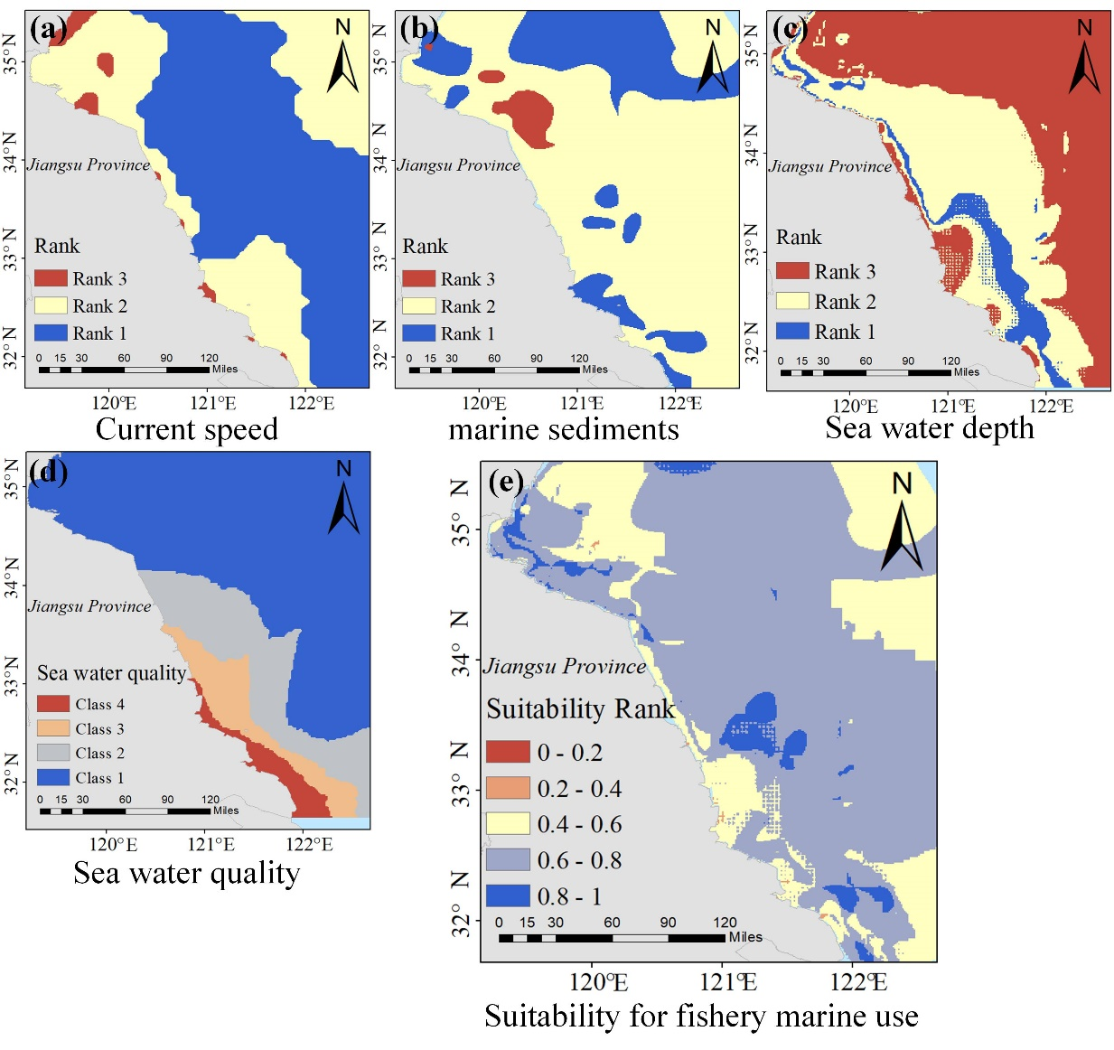

**Figure 4** Standardized layers for each criterion and the suitability assessment result for fishery marine use

## 2.4 The suitability assessment for wind farm marine use

The environmental factors for assessing the marine wind farm suitability include the wind speed, wave high, distance to the coastal line, water depth, distance from ship channel. The data for assessment is from multi-source, which is listed in Table 8.

**Table 8** The data sources for evaluating the suitability of wind farm marine use

|  |  |  |  |
| --- | --- | --- | --- |
| Marine use type | Data name | Time | Data source |
| Offshore wind farm | Wind speed | 2023 month mean | EAR5 datasets from https://cds.climate.copernicus.eu/ |
| Wave high | 2023 month mean | EAR5 datasets from https://cds.climate.copernicus.eu/ |
| Water depth | — | ETOPO1 dataset from https://www.ncei.noaa.gov |
| Distance form coastal line | — | Coastal line is publicly available from https://www.ngdc.noaa.gov/  mgg/shorelines/shorelines.html |
| Distance from ship channel | — | Ship routes are officially recommended  by Maritme Safety Admininstration of the  People’s Republic of China |

The data for calculation is preprocessed by missing value filling and spatial interpolation to unify the spatial resolution. The weight for each criterion reference the research of (Tercan *et al.*, 2020) The annual average of the data is used to perform the standardization. The criteria’s standardization function and their weights are performed in Table 9.

**Table 9** The Standardization function and weights for evaluating the suitability of ship navigation marine use

|  |  |  |  |
| --- | --- | --- | --- |
| Criteria | Positive/ negative | Standardization function | Weight |
| Wind speed | Positive |  | 0.4 |
| Wave high | Negative |  | 0.2 |
| Water depth | Positive |  | 0.1 |
| Coastal line distance | Negative |  | 0.1 |
| Distance from ship channel | Negative |  | 0.2 |

The standardized layer and the suitability assessment result for wind farm marine use are performed in Figure 5, where the Figure 5(a-e) performed the standardized layer for each criterion, and the Figure 5 (f) represent the assessment result.

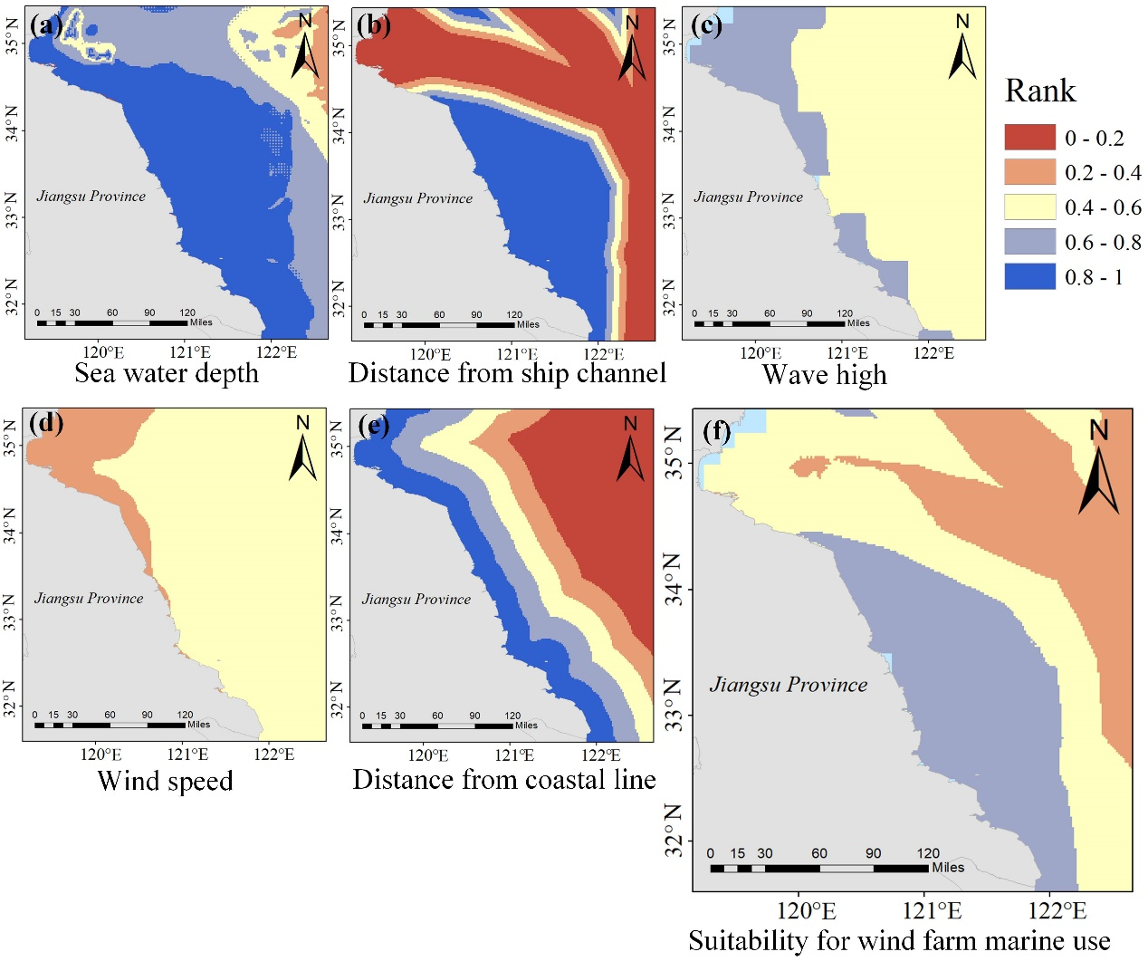

**Figure 5** Standardized layers for each criterion and the suitability assessment result for fishery marine use

## 2.5 The suitability assessment for sea salt production marine use

The environmental factors for assessing the suitability of sea salt production marine use include the marine salinity and distance from coastal line. The data source is listed in Table 10.

**Table 10** The data sources for evaluating the suitability of sea salt production marine use

|  |  |  |  |
| --- | --- | --- | --- |
| Marine use type | Data name | Time | Data source |
| marine use for salt production | Salinity | 2023  amonth mean | Publicly available from HYCOM datasets in https://www.ncei.noaa.gov/thredds-coastal/catalog/hycom_sfc/catalog.html |
| Distance from coastal line | — | Coastal line is publicly available from https://www.ngdc.noaa.gov/  mgg/shorelines/shorelines.html |

The distance from coastal line for sea salt production is preprocess by distance limitation, that only marine areas within 40 kilometers can be zoned for salt production. The criteria’s standardization function and their weights are performed in Table 11.

**Table 11** The Standardization function and weights for evaluating the suitability of sea salt production marine use

|  |  |  |  |
| --- | --- | --- | --- |
| Criteria | Positive/ negative | Standardization function | Weight |
| Salinity | Positive |  | 0.2 |
| Distance from ship channel | Negative |  | 0.1 |

The standardized layer and the suitability assessment result for sea salt production marine use are performed in Figure 6, where the Figure 6(a-b) performed the standardized layer for each criterion, and the Figure 6 (c) represent the assessment result.

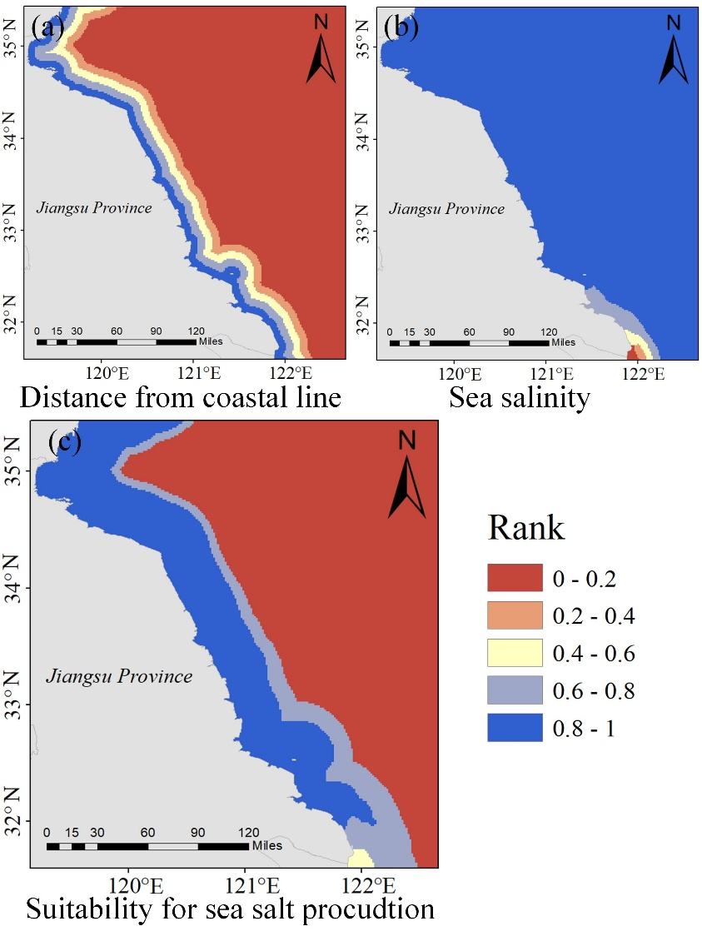

**Figure 6** Standardized layers for each criterion and the suitability assessment result for sea salt production marine use

# References

Dapueto, G., F. Massa, S. Costa, L. Cimoli, E. Olivari, M. Chiantore, B. Federici, and P. Povero (2015), A spatial multi-criteria evaluation for site selection of offshore marine fish farm in the Ligurian Sea, Italy. *Ocean & Coastal Management*, *116*, 64-77. https://doi.org/10.1016/j.ocecoaman.2015.06.030

Du, P., Z. Zeng, Y. Shen, and S. Liu (2023), Maritime risk assessment using a non-linear spatial multi-criteria decision method: A case study in the Bohai Sea and Yellow Sea, China. *Ocean Engineering*, *288*, 115994. https://doi.org/10.1016/j.oceaneng.2023.115994

Tercan, E., S. Tapkin, D. Latinopoulos, M. A. Dereli, A. Tsiropoulos, and M. F. Ak (2020), A GIS-based multi-criteria model for offshore wind energy power plants site selection in both sides of the Aegean Sea. *Environmental Monitoring and Assessment*, *192*(10), 652. https://doi.org/10.1007/s10661-020-08603-9